Due Task Year View

Need Visual aid of all Due Tasks: Tasks due over time

This is BIG data

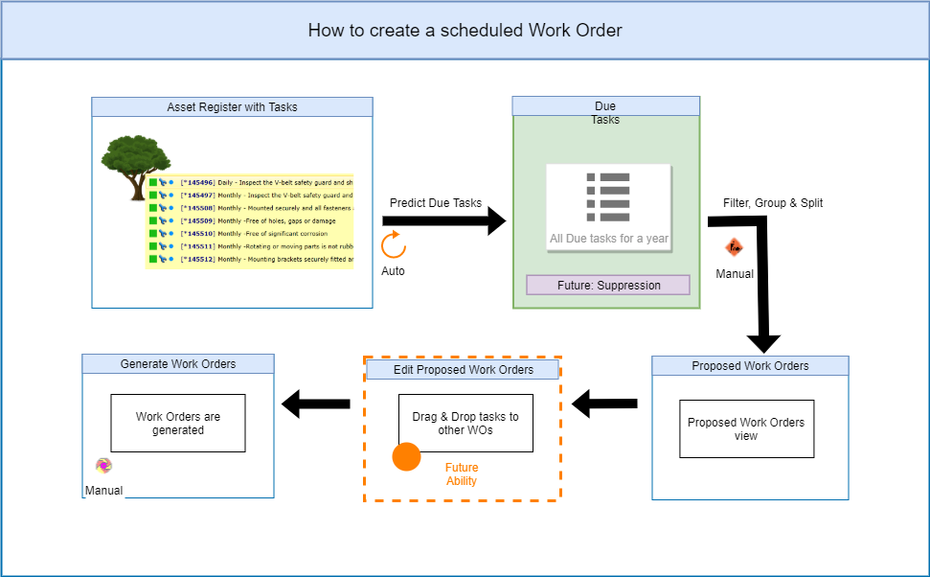

1. **Requirements:**

* Should see tasks in date format, in future
* Should be able to zoom in & out, to see more detail (day, week, month, year views)
* Filter functionality: what tasks to look at
  + Site
  + Asset Type
  + Asset
  + Event *– up for discussion*
  + Interval Type
  + Ability to add more filters: Location, Section, General Ledger etc.
* Display Options: show specific detail
  + Spares
  + Downtime / Duration (this could be a separate visualisation)
  + Resources (Labour & Special Resources)
  + Different Statuses
    - Due Tasks
    - Suppressed Tasks
    - Proposed Tasks (display in a group, the proposed WO)
    - Already tasks on an open WO (display in a group, the WO) *– up for discussion*
  + Auxiliary Tasks (part of main task) *– up for discussion*
  + Interval (not actual interval set by Conditions, but the default interval)
* Toggle to dashboard view & have option to export for planning purposes

1. Use Cases:

* Main reason: Resource planning (people & spares)
* As a planner I need to see what spares are required and by when
* As a Maintenance Manager I need to perform resource levelling. This is a very hard task to perform without information. Resource levelling is to make sure your technicians’ labour is spread out over the year, with the reduction of labour required spikes. Example: I only have 5 technicians, all 5 are required during a crane shutdown, thus I cannot have a crane shutdown activity at the same time as another activity. Then the next month there are no scheduled activities and thus all my technicians do not have work to perform. The dues list will assist me in changing the due dates of some major activities, so my labour utilisation is higher throughout the year.
* As the finance manager I need to what spares are required and by when to assist with accurate budgeting
* As a production manager I need to know when what assets will be down & for how long to plan output forecasting
* As an engineering manager I need to know how many people to employ for the year, I need to know how many people I need of a specific trade. (look at number of tasks for specific trade and duration thereof)
* As a manager I need to know when my people may take leave, they cannot all take leave when there is a lot of work due
* As an HSSE manager I need to ensure all required Statutory tasks have been scheduled for the year and use it as proof for compliance certificates. (tasks are marked as Statutory)
* As a Foreman I need to know which tasks can only be performed on non-working days so I can organise with the production manager not to produce on that day.
* As a planner I need to scrutinise the Dues list, I might see something that does not seem right to me, like some task being due when I am not expecting it. I need to be able to open the task and see all required details, such as ‘last done date’
* As a reliability engineer, I need to do Life Cycle costing to see when to rather replace or keep on maintaining an asset. The dues list will assist me in understanding what maintenance activities is on its way and the resources (with their cost) associated with the maintenance.
* If I rent out my equipment to a retailer, I need to be able to inform the retailer of when this equipment will be worked on, thus be unavailable for production. The retailer needs to be informed way in advance of such activities.
* The capex process is a lengthy process, as a planner I need my spares to be available for maintenance at the right time, but I know capex takes long. Thus I need to start the process of ordering a spare way in advance. The dues list can tell me by when I need the spare, thus I will know when to start the capex process.